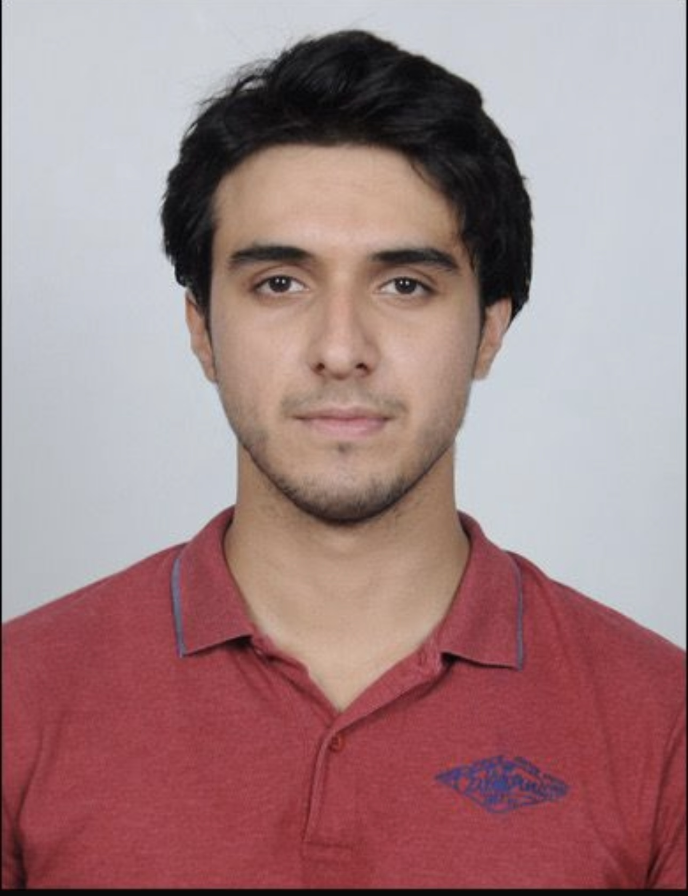  CONTACT  Pune, Maharashtra  9797778062  leokhurram02@gmail.com  LANGUAGES  English  Hindi  Urdu  Arabic  CORE COMPETENCIES  • Team Leadership & Event Management  • Client Relationship Management  • Marketing & Market Research  • Competitor Analysis & Data Collection  • Social Media Marketing  • Customer Service & Relationship Management  • Student / Client Communication  • Lead Follow-up & Enquiry Handling  • Counselling & Persuasion  • Administrative Coordination  • Teamwork & Coordination  • Professional Phone / WhatsApp Communication  • MS Office & Basic Computer Skills  • Time Management  WHY I FIT THE ROLE  • Multi-industry experience — events, fashion/marketing and administration — with strong people skills  • Proven team leadership — led and coordinated teams across multiple cities  • Follow-up focused — maintains regular communication through to resolution  • Professional approach to customer-facing conversations  • Fast learner — quick to pick up Speakwell's courses, counselling process and admissions procedures | KHURRAM JAVAID  BBA – Business Analytics | Team Leadership • Marketing & Research • Education Counselling • Administration  PROFESSIONAL SUMMARY  Motivated and versatile BBA – Business Analytics student with hands-on experience spanning event coordination and team leadership in the modelling industry, marketing and research in the fashion sector, and administrative/customer-facing roles. Skilled at leading teams, managing client relationships, coordinating multi-stakeholder events, and conducting market and competitor research. Interested in an Education Counsellor / Admin Executive role where strong communication, relationship-building and an organized approach can support student enquiries, counselling and admissions. Quick to learn new course information and comfortable working in a fast-paced, customer-facing environment.  EDUCATION  Bachelor of Business Administration – Business Analytics (BBA-BA)  MIT World Peace University (MIT-WPU), Pune • Currently Pursuing  RELEVANT EXPERIENCE  Team Leader / Event Coordinator & Manager — Blanckanvas Media by Minaaz — Kashmir & Pune  • Led and managed a team as Team Leader, overseeing coordination for the company's events across Kashmir and Pune.  • Acted as manager for ongoing events, managing suites, event logistics and on-ground execution.  • Built and maintained client relationships, ensuring requirements were understood and delivered on.  • Coordinated across teams and locations to keep events running smoothly, developing strong leadership and organizational skills.  Marketing Analyst & Manager — Gold Leaf Fashion Studio  • Worked as Marketing Analyst and Manager, driving marketing campaigns and social media initiatives for the studio.  • Conducted market research and competitor analysis to inform marketing strategy and positioning.  • Collected and analyzed client data to guide outreach and campaign decisions.  • Managed client outreach, strengthening relationships and supporting business development.  Business / Project Intern — Vidisha Constructions  • Supported day-to-day business activities, coordination and assigned administrative tasks.  • Maintained professional communication while coordinating with people and following up on tasks.  • Developed workplace skills in organization, accountability, communication and timely execution.  Customer & Influencer Coordination — Restaurant Promotion  • Coordinated with multiple influencers for a restaurant promotional campaign and managed communication.  • Handled briefing, scheduling, confirmations and follow-ups across multiple participants.  • Resolved coordination issues professionally and ensured requirements were communicated clearly.  • Strengthened customer-facing communication, relationship management and persuasion skills.  References available on request.

